SEP # : ??

Title: Simulink import
Version: 1.0
Author: Jerzy Zagórski
Review:
Commented:
State: Draft
Scilab-Version: 5.3
Vote:
Created : 18 may 2010

Abstract
This SEP describes idea for adding Simulink import functionality to Xcos. It's main goal is to give easy method of migrating Simulink diagrams to Xcos, with minimal user involvement.

Rationale
At this time migrating Xcos scheme to Simulink is almost impossible. It requires the user to create entire diagram from scratch. It is unacceptable for many reasons, such as : great amount of time needed, required knowledge of both Simulink and Xcos, required license for Matlab/Simulink during whole (sometimes very long) migration process.

Example Usage
Simulink import will be available to user via batch functions, and menu entries.
sim2xcos

sim2xcos('filename.mdl');
Translates and loads diagram from mdl file to new Xcos window.

sim2xcos('simulink file path', 'result path');
Translates diagram from .mdl file to .xcos file.

sim2xcos();
Opens window with file selection, after file selection model is imported and opened in new Xcos window.

scs_m = sim2xcos('filename.mdl');
Creates xcos_diagram from .mdl file.
It can be also good idea to add 'display information mode' choice with verbose ('errors', 'full') parameter.
menu entries

Simulink import will be also available as 'File' menu entry in Xcos.

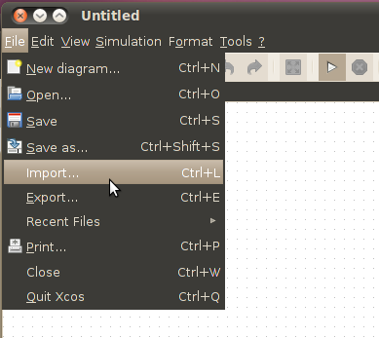
Selecting 'Import...' from menu will open import dialog:
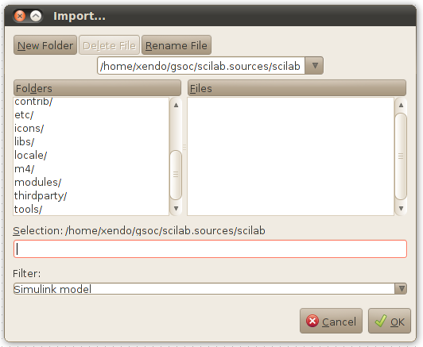
After selecting model to import, imported diagram will be opened in current Xcos window.
It would be great to add 'Simulink import' to Matlab to Scilab translator. 'Simulink import' will have to import every model invoked by matlab 'sim' function, and then run it with scicos_sim() and proper parameters.

Implementation

Logger

Obvious part, every error and finished stage of migration should be clearly logged. Then it will be used when displaying information and progress of import in scilab batch.

Parser

There is already very convenient way of parsing Simulink model files. Conqat is an open source project (licensed under Apache License 2.0) that provides Java's Simulink parser library. It's well documented and I think it should be the best existing solution. Sample usage of this parser can look like this:
SimulinkModelBuilder builder
= new SimulinkModelBuilder(new"), new SimpleLogger());
SimulinkModel model = builder.buildModel();
then every block, parameter can be accessed by simply:
public static void readSimulinkBlock(SimulinkBlock block) {
UnmodifiableIterator<SimulinkBlock> blockIter = block.getSubBlocks().iterator();
while(blockIter.hasNext()) {
readSimulinkBlock(blockIter.next());
}
}
Below, the class diagram (of Conqat Simulink Model) that clearly shows how Simulink models should be processed:

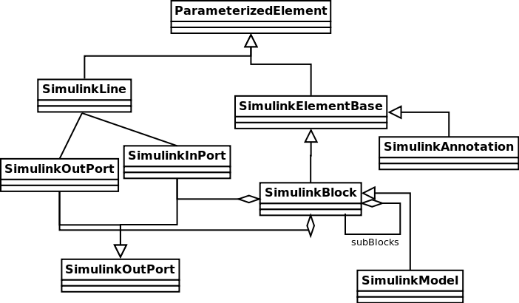

Mapper

This step is the most demanding in whole idea of creating 'Simulink Import'. It requires implementing compatibility patterns for evaluation functions and block representations (and there are a lot functions and block in simulink). In this part I'll create some clean XML migration schema and process it using JAXB (Java Architecture for XML Binding).
All mapping will be conducted directly. Recursively accessed blocks (every block can be subsystem) will be decoded straight (just like in io.scicos) to XcosDiagram via binded XML migration schema. Every element of Simulink diagram will be checked during decoding (in case of troubles proper logs should be made).
Sample code presenting decoding process of created earlier model:
DiagramElement diagram = new DiagramElement();
try {
XcosDiagram into = diagram.decode(model, null);
} catch(SimulinkFormatException e1) {
LogFactory.getLog(ImportMdl.class).error(e1);
}
We can make possible to manually correct the diagram after unsuccessful importation, that is why giving good feedback from mapper is even more important. After this stage of import we should have existing XcosDiagram structure.

Examples
Very simple simulink schema:

Output generated by first parser (list of parameters of diagram, and two blocks):
From DiagramElement.decodeDiagram:
[ExtModeEnableFloating, BlockRotation, RTWModifiedTimeStamp, LastModifiedDate, FontSize, ShowPortDataTypes, LastModifiedBy, AccelSystemTargetFile, CovNameIncrementing, ModifiedByFormat, BrowserLookUnderMasks, ShowSignalResolutionIcons, SaveDefaultBlockParams, CovHtmlReporting, MdlSubVersion, ExtModeTrigDirection, BlockDescriptionStringDataTip, CovCumulativeReport, CovSaveName, Profile, ExtModeTrigPort, ExtModeIncDirWhenArm, CovModelRefEnable, ExtModeArmWhenConnect, SortedOrder, SimulationMode, ExtModeTrigDuration, ExtModeAutoUpdateStatusClock, StatusBar, ExtModeTrigType, BrowserShowLibraryLinks, DataTypeOverride, CovForceBlockReductionOff, ExtModeTrigElement, ExtModeTrigDurationFloating, UpdateHistory, CovMetricSettings, ExtModeAddSuffixToVar, FontName, ExtModeTrigHoldOff, ShowLoopsOnError, CovCumulativeVarName, BlockParametersDataTip, MinMaxOverflowLogging, covSaveCumulativeToWorkspaceVar, BufferReuse, ShowLinearizationAnnotations, BlockMirror, MaxMDLFileLineLength, ModelVersionFormat, LibraryLinkDisplay, ExtModeTrigDelay, ExtModeAutoIncOneShot, ExtModeBatchMode, CovReportOnPause, DropShadow, ScopeRefreshTime, MinMaxOverflowArchiveMode, WideLines, SampleTimeAnnotations, CovExternalEMLEnable, ShowModelReferenceBlockVersion, ShowModelReferenceBlockIO, BlockNameDataTip, SampleTimeColors, Version, ExtModeTrigLevel, ExtModeArchiveMode, NamePlacement, DisableAllScopes, SavedCharacterEncoding, ToolBar, FontWeight, FontAngle, CovSaveSingleToWorkspaceVar, ForegroundColor, ShowStorageClass, ParamWorkspaceSource, IgnoreBidirectionalLines, RecordCoverage, ModifiedDateFormat, ExtModeLogAll, LinearizationMsg, ExecutionContextIcon, BackgroundColor, CovPath, ShowViewerIcons, Created, TryForcingSFcnDF, AccelTemplateMakefile, ExtModeWriteAllDataToWs, OverrideScopeRefreshTime, ShowLineDimensions, Creator, ExtModeTrigMode, Name, ConfigurationManager, ShowTestPointIcons, AccelMakeCommand, ShowName, ExtModeSkipDownloadWhenConnect]
From BasicBlock.decode:
[Open, DropShadow, BlockRotation, MaxDataPoints, FontSize, Floating, ModelBased, BackgroundColor, Grid, NumInputPorts, BlockType, SampleInput, LimitDataPoints, YMax, NamePlacement, DataFormat, FontName, Location, FontWeight, SaveToWorkspace, FontAngle, SID, Name, BlockMirror, ForegroundColor, TimeRange, TickLabels, Decimation, SaveName, ZoomMode, YMin, Position, SampleTime, ShowName, Ports]
From BasicBlock.decode:
[DropShadow, BlockRotation, OutMin, FontSize, BackgroundColor, ConRadixGroup, OutDataType, BlockType, OutDataTypeMode, OutMax, Value, NamePlacement, LockScale, FontName, FontWeight, SamplingMode, OutDataTypeStr, FontAngle, SID, Name, FramePeriod, ForegroundColor, BlockMirror, OutScaling, Position, SampleTime, VectorParams1D, ShowName]
All of this values should be translated into corresponding Xcos parameters.

User Feedback
If everything goes write, it will be great to receive user feedback from 'Simulink Import'. It's easy way of knowing what Simulink functionality they miss the most, and where the problems occur during translation.

Changelog
  - – First draft
  - - Added class diagram of Conqat Simulink Library
  - - Changed Mapper section (JAXB instead of libxml2, and added io.scicos like decoding)
  - - Added Examples section

Copyright
This document has been placed under the licence CeCILL-B.

